**MARK ANTHONY S. TIMARIO**

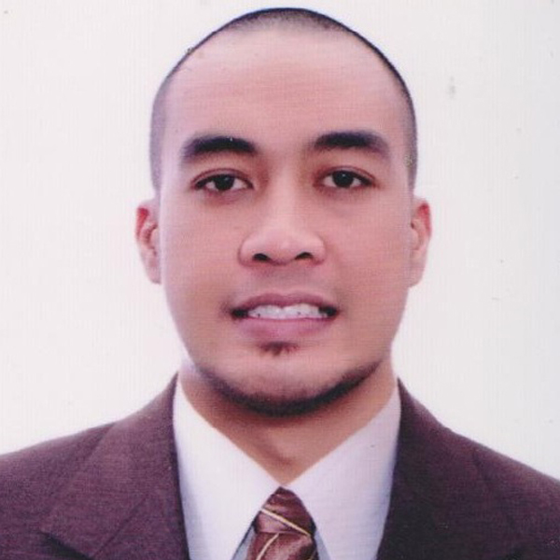

**Photo**

**2x2**

27 Gen. Delgado St. Brgy. San Antonio, Pasig City, Philippines

Cellphone No.: 09991040795

Email Address: markanthonytimario21@gmail.com

## Career Objective: To belong in an institution that would maximize my full potential as a Information Technologist and allow me to be of efficient service to others.

**Areas of Expertise:** Software /Hardware

**Professional Qualifications**

**Education**

* Tertiary : Jose Rizal University

Bachelor of Commercial Science Major in Computer Science

#80 Shaw Boulevard, Madaluyong City

Year Graduated : 2010

* Secondary : Kapitolyo High School

San Ignacio St. Bo. Kapitolyo, Pasig City

Year Graduated : 2005

* Primary : Oranbo Elementary School

Oranbo Drive, Pasig City

Year Graduated : 2001

**Systems Trained/Maintained**

* National Blood Bank Network System (NBBNetS)
* Adverse Drug Reaction Online Reporting System (ADORS)
* Online National Electronic Injury Surveillance System (ONEISS)
* Electronic Drug Price Monitoring System(EDPMS)
* Integrated Chronic Non-Communicable Diseases Registry System(ICNDRS)

**Qualification**

* Willing to enhance my skills in Computer Programming.
* Willing to enhance my skills in Networking and LAN.
* Willing to learn and associate with other people.
* Willing to render extended hours to work.
* Honest, trustworthy, optimistic and hard-working

**Training/Seminars attended**

* Training on National Blood Bank Network Svstem (NBBNetS) on December 27-28, 2018 at Northern Mindanao MedicalCenter, Cagayan De Oro Citv
* Training on National Blood Bank Network Svstem (NBBNetS) on September 18-20, 2018 at Legazpi City
* Orientation on the Implementation of National Blood Bank Network System (NBBNetS) Otel Pampanga, Lazatin Blvd, City of San Fernando, Pampanga - August 13, 2018
* Technical Assitance and Install the National Blood Bank Network System (NBBNets) on Governor Celestino Gallares Memorial Hospital, Tagbilaran City, Bohol - May 7-9, 2018
* Technical Assistance and Install the National Blood Bank Network System (NBBNetS) in Bataan Provincial Hospital Balanga City, Bataan - March 14-16, 2018
* National Voluntarv Blood Services Program (DOH — NVBSP) training for the Integrated Blood Bank Information System in line with the Implementation and Standard Procedures for the NBBNets on December4-6, 2017 in Bataan ProvincialHospital,Balanga Citv, Bataan
* National Voluntary Blood Services Prosram (NVBSP) Technical Assistance and Install the National Blood

Bank Network Svstem (NBBNetS) software on Cotabato Regional and Medical Center - January 16-21,2017

* NVBSP Hospital wide Implementation of Transfusion Module of NBBNets and Training of Nurse Users of Corazon Locsin Montelibano Memorial Regional Hospital - November 17-18, 2016
* Technical Assistance and Install the National Blood Bank Network Svstem (NBBNetS) in Cotabato Regional and Medical Center - October 12 to 19.2016.
* NVBSP Technical assistance and install the NBBNetS software on Corazon Locsin Montelibano Memorial Regional Hospital - August 3l to September3,2016.
* TechnicalAssistance and Install the National Blood Bank Network Svstem (NBBNets) - Region VII Blood Center December 19, 2015
* TechnicalAssistance and Install the National Blood Bank Network Svstem (NBBNets) - Bicol Regional Blood
* Center December 21-22, 2015
* TechnicalAssistance and Install the National Blood Bank Network Svstem (NBBNets) - CagayanValley
* Medical Center December 28, 2015
* TechnicalAssistance and Install the National Blood Bank Network Svstem (NBBNets) - Eastern Visayas
* TechnicalAssistance and Install the National Blood Bank Network Svstem (NBBNets) - Regional Medical Center August 25-27, 2015
* TechnicalAssistance and Install the National Blood Bank Network Svstem (NBBNets) – The Medical City, Ortigas Avenue, Pasig City – June 30, 2015
* Conduct Hand-on-Training on National Blood Bank Network System (NBBNetS) at NCR (Victor R. Potenciano Medical Center) EDSA, Mandaluyong City - May 21, 2015
* TechnicalAssistance and Install the National Blood Bank Network Svstem (NBBNets) – Batangas Medical Center – March 10-12, 2015
* TechnicalAssistance and Install the National Blood Bank Network Svstem (NBBNets) – Region XI (Davao Region) – December 10-13, 2015
* Cotabato Regional and Medical Center - October 12 to 19.2016.
* DOH-IMS, Information Systems Standard Writeshop - November 28 to December 2, 2011
* DOH-IMS, Annual User’s Conference and System Updates on the Online National Electronic Injury Surveillance System(ONEISS) and Kontra Paputok (KP - November 23-24, 2011
* DOH-IMS, Attended Advance Technical Training on the Electronic Drug Price Monitoring System (EDPMS) November 15-18, 2011
* DOH-IMS, User’s Training on the Integrated Chronic Non-Communicable Dieses Registry System (ICNCDRS) September 22-23 to 27-30, 2011
* DOH-IMS, Basic Training Course on Effective Presentation Techniques in Conducting Training Courses September 14-15 , 2011
* DOH-IMS, Training of Trainer’s on the Enhance Web Base Public Assistance Information System (E-WEBPAIS) August 24-25, 2011
* DOH-IMS, Comprehensive Trainings on the Computerized Payroll System(CPS),Online Document Tracking Information System(ODTIS),Personnel Information System(PIS) August 1-19, 2011
* DOH-IMS, Adverse Drug Online Reporting System (ADORS) July 26-29, 2011
* DOH-IMS, Power Builder Programming, July 11-15, 2011
* DOH-IMS, Joomla Web Programming, July 14-15, 2011
* DOH-IMS, PHP Scripting Language, July 4-6, 2011
* DOH-IMS, On-the-Job Training on Hospital Operations and Management Information System

(HOMIS), June 20 - July 1 2011

* DOH-IMS, Program Logic Formulation, June 16-17, 2011
* DOH-IMS, Database Management June 14-15, 2011
* DOH-IMS ,DOH ICT Standards, June 13, 2011
* DOH-NCDPC/DDO ,System Performance Evaluation Of ONEISS, ADORS, e-FHSIS

ICNCDRS, PNIDMS, UHMIS, November 24-26 2011

* DOH-IMS, Online National Electronic Injury Surveillance System, October 4-6, 2011
* Jose Rizal University Computer Society, Member, 2009-2010
* Jose Rizal University Math Society, Member, 2006-2009

**Employment History**

**Department of Health**

National Blood Bank Network System

Rizal Avenue, San Lazaro Compound, Sta.Cruz, Manila

Position: Computer Programmer III

February 1, 2013 – Present

* Write, update, and maintain the NBBNetS, National Sandugo On-Line Evaluation System and Donor Recruitment System.
* Acts as Liaison to the developers of NBBNetS.
* Act as one of the programmers in the system integration of NBBNetS, TPD-S and Donor Management.
* Ensure the integrity, security, and the 24/7 availability of an existing Blood Banking Information System including but not limited to the NBBNetS.
* Conducts system analysis and development with limited support and direction.
* Research new technologist and present recommendations and justifications on major hardware and software purchases.
* Develops and test new servers and services including writing scripts and patching existing source code/s.
* Performs regular monitoring of system.
* Performs other related functions as maybe assigned.

**Department of Health**

National Center for Disease Prevention and Control-National Electronic Injury Surveillance System

Rizal Avenue, San Lazaro Compound, Sta.Cruz, Manila

Position: Data Encoder II

September 16, 2010 – February 1, 2013

* Know and understand current software operations of the ONEISS and further updates on the system
* Respond to software related questions or queries in person, via emails and telephones.
* Attend to and/or troubleshoot software, hardware, network, users’ access, and other related technical problems
* Provide software operations training to CHDs and users of the system
* Closely check and monitor the reporting or updating of data and ensure that the system is up 24x7
* Provide and issue usernames and passwords as recommended and approved by the NCDPC.
* Perform necessary hardware and installations.

**Software Ventures Int'l. (SVI) - BPO Division**

Position: Encoder (Part-time)

6f JMT Corporate Condo ADB Ave.,Ortigas, Pasig 1605

March 29, 2010 – September 16, 2010

* Encoding Hungarian Baptismal Record

**Software Ventures Int'l. (SVI) - BPO Division**

Position: Encoder (On the job trainee)

SVI Software Ventures International

6f JMT Corporate Condo ADB Ave.,Ortigas, Pasig 1605

December 28, 2009 - February 12, 2010

* Encoding Hungarian Baptismal Record

**Personal Information**

* Date of Birth : February 5, 1988
* Birth Place : Camp Crame, Quezon City
* Gender : Male
* Marital status : Married
* Citizenship : Filipino
* Languages / Dialects Spoken : Tagalog, English,
* Contact person in case of emergency : Janice C. Timario / Contact No.: 09283248408

**References**

Name Contact Number

1. Dr. Pedrito Y. Tagayuna ,MD, FPSP +632-514-1549
2. Ms. Jovita V. Aragona +632-924-6601
3. Ms. Concepcion S. Liberan +632-924-6101

*Resume prepared on: January 15, 2019*